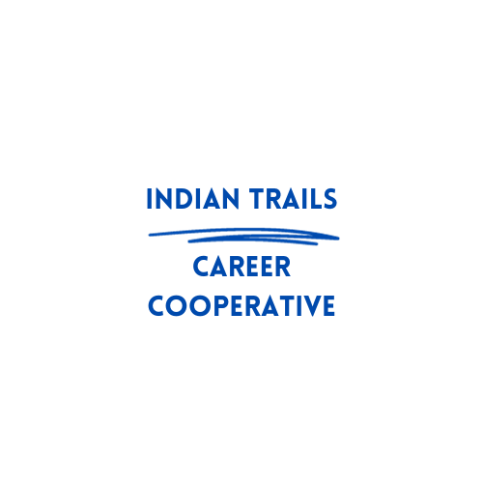  Professional Development Request Form | - Please fill out the Professional Development Form as much as you can.  - Keep the checklist at the end to keep track of the things you need to turn in. We cannot process reimbursement until all items are turned in.  - You will click on the “click here to enter text” boxes to fill out the form.  - The “Choose an Item” boxes are drop downs where you will make your selection.  - Please do not forget to enter the Total estimated cost.  - Forms must be signed by your building principal and then sent to Indian Trails.  - A written summary of what you learned at the conference/activity and how you will use it is required for reimbursement.  - Watch your mail --- reimbursement checks come in a Twin Lakes School Corporation envelope.  - Sub reimbursement request needs to be submitted to us by your corporation office.  - We do not reimburse for meals.  - Requests without at least three weeks’ notice may not be accepted.

Indian Trails Professional Development Request Form
Name: Click or tap here to enter text.
School: Choose an item.
Date: Click or tap to enter a date.
Name/Title of Conference/Activity: Click or tap here to enter text.
Location of Conference/Activity: Click or tap here to enter text.
Date of Activity: Click or tap here to enter text.

Expenses
Registration: $ Click or tap here to enter text.

Travel Method: Choose an item. | # of miles or cost of flight: Click or tap here to enter text.
Lodging: # of Nights: Choose an item.

Lodging Rate (per night): $ Click or tap here to enter text.  (not to exceed conference hotel rate) | Conference hotel rate (per night): $ Click or tap here to enter text.
Sub teacher pay (per day): $ Click or tap here to enter text. | Baggage, parking, tolls: $ Click or tap here to enter text.
TOTAL Estimated Cost: $ Click or tap here to enter text.

- To qualify for a PD activity, you must have an active advisory committee and be current on meetings with minutes submitted to Indian Trails.
- Mileage will be calculated from your high school address, not your home address. Mileage will be paid up to the cost of an airline ticket. You will need to submit a mileage claim form.
- Annual Program Evaluation up to date and submitted.
- Itemized receipts required for all expenses.
- A written trip report with a summary of session attended and how you can utilize what was presented. This must be submitted with your itemized receipts, otherwise you will not be reimbursed until we receive a written summary.
- Most expenses are to be paid by the individual: Indian Trails will then reimburse you.
- If the individual does not attend the conference/activity, the individual is expected to reimburse Indian Trails any monies they have paid out.
- Reimbursement checks will come from Twin Lakes School Corporation.

___________________________________________ ___________________________________
Building Principal Signature CTE Director Signature
___________________________________________ ___________________________________
Date Date
Check list of things to turn in
(You need to keep this page)

Signed Professional Development Request ☐

Items to Turn in After Attending Professional Development:
Registration Receipt ☐
Flight Receipt or Mileage Form ☐
Hotel Receipt ☐
Baggage, parking, toll receipts (if applicable) ☐
Written summary of PD (no longer than one page) ☐

